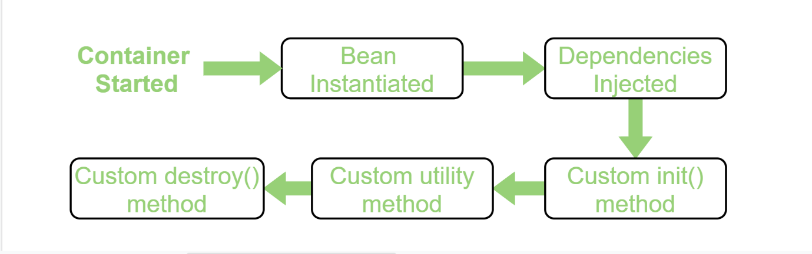

Spring is dependency injection which is possible because Spring is a container and behaves as a factory of Beans. Just like the BeanFactory interface is the simplest container providing an advanced configuration mechanism to instantiate, configure, and manage the life cycle of beans.
Beans are Java objects that are configured at run-time by Spring IoC Container. BeanFactory represents a basic IoC container which is a parent interface of ApplicationContext. BeanFactory uses Beans and their dependencies metadata to create and configure them at run-time. BeanFactory loads the bean definitions and dependency amongst the beans based on a configuration file (XML) or the beans can be directly returned when required using Java Configuration.
BeanFactory does not support Annotation-based configuration whereas ApplicationContext does.

